Day 5 – Recent Award Winners

Welcome to Day#5. This is strategy #1 of winning your first federal contract.

In today’s lesson we are using 3 commonly know websites (FBO, FPDS and Daily Bulletin) to identify companies who were recently awarded federal contracts related to our NAICS code and then soliciting that firm for opportunities.

Every company in the world uses suppliers and/or subcontractors to help facilitate the manufacturing, distribution and sales of their products and services. Here we are simply targeting those firms in the federal arena.

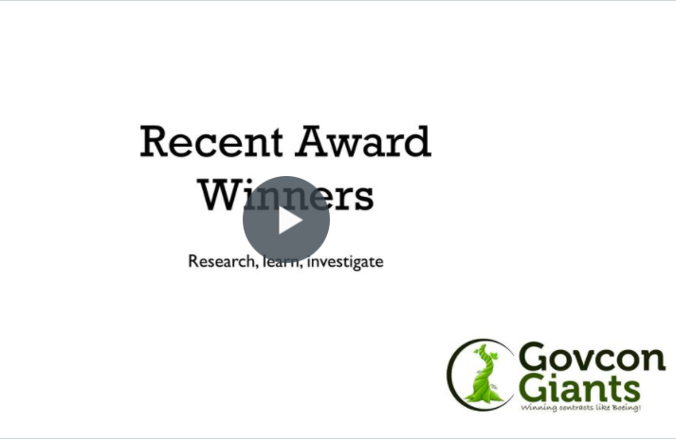

Complete Strategy #1

FYI: As an experienced government contractor I know that the struggle to find and keep good subcontractors and suppliers is an ongoing challenge. There is always room for one (1) more.

Eric Coffie

